T A

_____ _____

12 88

**NAME:__________**

**THEORY TEST: INTERVALS**

**CLASS: ____**

**APPLICATION**

__

40



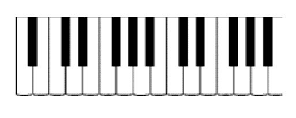

**APPLICATION**

__

24



**THINKING**

**APPLICATION**

__

24





__

12